From Nereid to Artemis: the mythical representation in fashion advertising

Amanda Queiroz Camposa, Richard Perassib and Luiz Salomão Ribas Gomezc

a Department of Industrial Design, Berguische Universität Wuppertal

*Department of Graphic Expression, Federal Univeristy of Santa Catarina*

Germany/Brazil

amandaqc8@gmail.com

b *Department of Graphic Expression, Federal Univeristy of Santa Catarina*

Florianópolis, Brazil

richard.perassi@uol.com.br

c *Department of Graphic Expression, Federal Univeristy of Santa Catarina*

*UNIDCOM, IADE – Creative University*

Brazil/Portugal

salodesigner@gmail.com

ABSTRACT

In the current fashion culture, the products commercialized by fashion brands are not considered the main focus of these brands. The products are seen as physical support to project the creative content that is disclosed by the brands. There is an obvious mythological appeal in the images used in this study, showing that the “mystification” process is a trend in the fashion culture.

**Keywords**: fashion; advertisement; branding; trends; mythology

INTRODUCTION

Due to the need to stimulate sales, investments have been focused on increasing consumption, based on the aesthetic-symbolic obsolescence of products that could be used for a longer time. The variation of themes and sensory or stylistic expressions in fashion products is based on the most common anthropological relations. Achievement promises that are constantly renewed. Currently, the fashion market is financially powerful and culturally influent. Investors celebrate, also, the power of socio-symbolic influence on this profitable business.

Besides the aesthetic-symbolic quality of materials and fashion products style and besides the stakeholders’ actions, the products and communication pieces also express typical aspects of the brand and fashion trends. Thus, the activities and products of Graphic Design and Publicity areas also take part in the individualization and characterization of the brand in the fashion culture context.

The creation, management and communication process of the fashion brand is subtle and intersubjective, considering that products are symbolically transient and the publicitary and commercial dynamics must be agile and effective. Products must be constantly innovated or adapted to the current trends; however, there is also the need to maintain the identity of the brand and its positive image towards the public.

The activities and products of Graphic Design and Publicity areas, more specifically, discourse about the positioning and values that compose the brand identity. The images analyzed here, belonging to the brands’ advertising campaign, are strategic elements for the creation and management processes of the brands, which are also seen as a management process of the fashion brand publicity visual communication.

METHODOLOGY

This research was based on the “descriptive” approach. In other words, even though the characteristics of the analyzed phenomena are presented, the assumptions are not unconditional. In order to scientifically validate the descriptive research, it is extremely important to define methods and theories for the data processing.

The data collection was longitudinal - characterized by the data collection during the research period, unlike transversal studies, which collect the data only once. Thus, the observation may be classified as constant. The data collection technique used was the systematic observation. For being qualitative, the data obtained was inductively analyzed, with support from the theory references that were reviewed for the research presented here.

THE FASHION CULTURAL SYSTEM

Fashion as a cultural phenomenon

According to the Culture Semiotics, culture is an aggregation of symbols and myths of a certain group, thus, fashion has culture. These symbols and myths, however, are not expressed by themselves, they express by means of the material culture. Thereby, every culture depends on an expression group so that the symbols and myths may be expressed and communicated.

The first reality is composed by tangible or material things. This reality is noted through sensations from characteristic relations of what is considered the natural or material world. The second reality is imaginative, symbolic and typically cultural, for their results are intangible and abstract.

The clothing, for example, is a part of the material culture of fashion that expresses its symbolic and mythical values. For Lipovetsky (1987) fashion is located in the immaterial field, however, the clothing provides fashion with materiality and expressivity. The outfits allow fashion to be exercised, once it is imaginative and belongs to a culture.

This aspect increases the relevance of fashion products, because they are signs of a language, presenting the personal and cultural texts as historic records of an individual or culture’s records.

The commercial culture of fashion

The creators of fashion act as filters for several change incentives, the fashion expressions also incite the changes by quickly and largely affecting the population. Unlike the arts, the fast renewal of fashion is directly motivated by financial-commercial interests. The creation and production of fashion items occur in industrial process, involving the industry of material consumer goods in the aesthetic-symbolic world of the cultural industry, whose production is conceptual.

The production cycle, from creation to completion, starts up to 18 months in advance. A type of research that is required supports the studies of cultural trends and their influence over the fashion consumer public. These trends are seen as signs that show consumption tastes, desires and moods (GODART, 2010).

There is an elemental duality in this industry, defined by its double nature, as artistic activity and as economic practice. The clothing industry, therefore, was developed due to specific temporalities

THE BRAND CULTURE

In the beginning, institutional and commercial brands were seen as a sign or group of physical signs, such as written or spoken names, graphic symbols or pictures, which were used to identify businesses and products, among others. However, the emotions or impressions and the ideas, which characterize the image of the brand or its reputation on the public’s mind, are becoming more and more an interesting object for scholars and administrators who establish a direct connection between the noticed signals and the impressions and ideas that these signals represent.

Originally, the brands appeared as physical signals that aim at identifying and signaling. Therefore, there is a concept of brand that characterizes it as a “name, term, signal, symbol or design, separate or combined with the purpose of identifying a promise of benefits, associated with goods or services, which increase the product value as well as its functional purpose, offering a tenable differential advantage” (TAVARES, 1998, p.21).

As an intangible asset, configured as positive or negative mental image of an organization, a product or a service, the brand is considered suchlike the reputation of a company (TYBOUT; CALKINS, 2006). In this sense, the “brand” is a combination of mental associations connected with visible expressions, such as name, signal, symbol, associated with an organization, product or service. “The brand is a complex system that involves several forms of expression: linguistic, visual and sonant, among others, which confer an identity to the product as well as a group of values, identifying it and outstanding it among the competitors” (GOMEZ, OLHATS E PÓLO, 2011, p.2).

Besides granting personality to its representation, the brand image is built as an affective-symbolic description of experiences with demonstrations of the brand without contact with the product and, moreover, the brand is the memory of what has been experienced with the product, even when it is not being used. The brands and the products represented by them are complementary elements, for the brands identify and represent the products and the products express and represent the brands.

For having distinct particularities, the products are instruments of market differentiation and segmentation. Yet, when they are not being used, the consumers communicate their impressions and report their personal experiences about the same type of product, identifying them by the brand, that is, by the name or format and specific colors. Thus, the brand is an extremely important element of differentiation from the competitors which, besides identifying and characterizing the product, also represent and transmit its image and message.

Mainly nowadays, the brands surpass the material functions and focus on the emotional appeal. The focus on experiences characterizes the current market scenario with a cheerful character and pre-disposal to self-indulgence. Therefore, the brands invest on the brand communication and the shopping and consumption experiences, aiming at overcoming the products’ material scope.

Lança Perfume

The brand Lança Perfume, also known by the initials LP, was created in 2006 as a secondary brand of a children’s brand, belonging to Group La Moda. The initial strategy was to hire the actress Monique Alfradique (works in a TV show for young people) to attract the desired market share, in this case, the women (figure 1).

After being nationally recognized in Brazil, and because the communication strategy was to show a more sophisticated and conceptual international brand (top models), the visual language of the brand’s advertising campaigns was improved to express the intended sophistication (figure 2), achieving its notoriety.

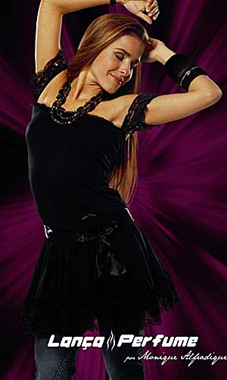 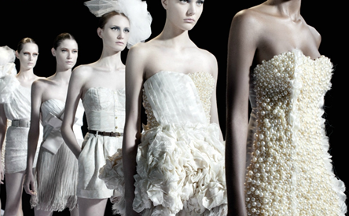

Figure 1: Lança Perfume’s Campaign featuring Monique Alfradique in 2006

Figure 2: Spring/Summer 2012 Lança Perfume’s Campaign

Morena Rosa

The brand Morena Rosa belongs to Group Morena Rosa, located in the city of Ciarnorte, state of Paraná. The group started the creation in 1993 when the company organization was informal, being described as a partnership among friends. In the following years, they created the brands Zinco and Maria Valentina and acquired the brand Joy. They work with a system of mini-collections.

The brand is intended for a young public, characterized by audacity, joviality, modernity and sensuality. The advertising campaigns for new collections are usually presented by models that the fashion public easily recognizes. Thus, the image of Morena Rosa has been associated with names of internationally known top models, as Carol Trentini (Image 3) and Isabelli Fontana for several collections. The choice of models confirms the strategy adopted by Lança Perfume and many other brands, whose intention is to add an international condition to the brand by associating it with Brazilian models who usually work in campaigns for luxury brands inside and outside the country.

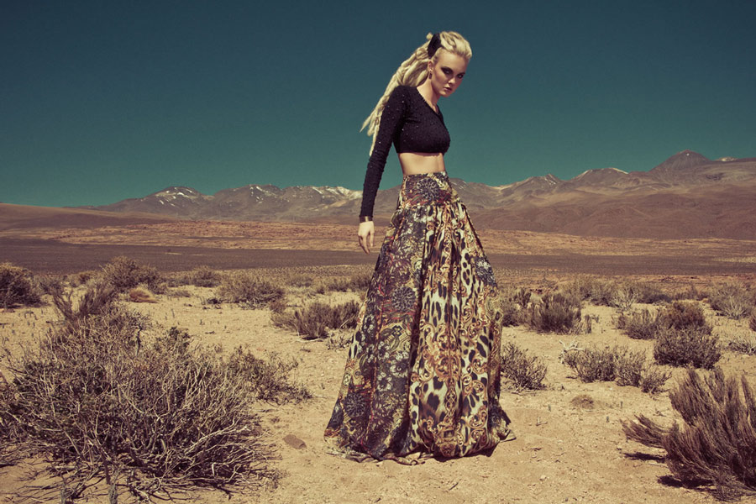

Figure 3. Autumm/Winter 2012 Morena Rosa’s Campaign

VISUAL AND CONCEPTUAL ELEMENTS OF THE VISUAL LANGUAGE

Any interpretation process may be considered complex, because they involve multiple dimensions altogether. Two of these dimensions will be discussed here: the aesthetical and the symbolic dimension. The choice of both dimensions confirms the Culture Semiotics choice; the interpretation was adapted to the aesthetic and symbolic dimensions. The aesthetic dimension is directly related with the first reality, which is physical or material. The symbolic dimension characterizes the second reality composed by conventional signals of the culture (LOSADA, 2010).

For having an aesthetic character, the visual language codification is established in a pre-metaphorical level, being initially dominated by visual syntax relationship (DONDIS, 1997). Thus, groups of associations and organizing principles of the aesthetical dimension are typical elements of the visual language.

It is important to study the visual language prior conjectures in order to understand its complete structure, which results from the elements’ specific qualities. Yet, in general, these specificities are produced in an interactive way to compose the image singularity as a cultural text with specific purposes.

Basic elements: point, line, plan and blur, with visual-expressive and non-metaphorical function. The interaction with the image’s visual elements: points, lines, flats and blurs suggest invisible elements, for they stimulate the observer’s imagination so that the observer may project images or concepts about the visual elements. Conceptual elements: shape, colors, textures, tones, deepness, movement, volume, proportionality, visual contrast, visual equilibrium, rhythm suggestion, perspective, direction, etc.

The complex and sophisticated possibilities of visual representation and language, however, are resultant from the capacity of the artist, illustrator or designer, among others. These professionals organize the basic visual elements to compose pictures and shapes with interesting visual qualities, besides organizing them in different sizes and positions so that they take part in the conceptual discourse that must be communicated by a composition or image.

Unlike the photography that registers natural or social reality aspects, the fashion photography, whose images are object of this study, is made of compositions resultant from projects that previously aimed at causing a relevant interference in the first reality. This way, the scenarios are composed and people are prepared to act as fashion models. The purpose is to present the clothing pieces and accessories as perfect outfits that make an ordinary event or special moment become a fairytale or a glamorous dream. Therefore, the photography is used to compose an illustration, overcoming the first reality and strongly investing in the visual language to aesthetically and symbolically promote an enchanted and enchanting second reality.

INDICATION OF THEMES IMPLIED IN THE IMAGES STUDIED

The purpose of this study was to describe the following themes and graphic-discursive resources in the visual information of the fashion pictures for the summer of 2013/2013 from brands Lança Perfume and Morena Rosa. The “mystification” was noted as an evident trend in the communication of both fashion brands being studied. Yet, each brand presented, Lança Perfume and Morena Rosa, makes use of the “mystification” trend in its own way.

The images studied, either by their narrative or their visual content, clearly show the mythical-symbolic intention. The mythical way of thought conceives that a natural situation is revealed by means of an experience as hierophany, in other words, as a sign of something magical and fantastic. Hierophanies are elements from the second reality, even when they occasionally correspond to perceptible phenomena (ELIADE, 1953). The myth is what reveals the expressivity, not the opposite. For, as well as other symbolic or spiritual beings, the purpose of its existence is to provide sense or significance to something.

The brands are symbolic or mythical because they exist in the psychological field, in the immaterial field of the second reality. They are entities that may be perceived by their expressions that refer to defined psychic contents, which are dynamic and malleable, for, as time goes, they shall adapt to behavioral changes of their consumers and to new cultural trends that constitute the context where the brands are inserted.

For Randazzo (1993), in the contemporary world, the mythologies have become indispensable again, because this is the postmodernism universe, characterized by the breaking up of identities. Thus, the role of mythology is to help rebuild the sense of identity outside the reality whirlpool, making the brand fantasy become visible over the materiality of the products and establishing their meanings. “The advertising wizard became the myth creator (...), pulling the strings of its commercial magic onto the blue sparkle of the electronic space and the consumers’ mind” (RANDAZZO, 1993, p.85). The Greek admired the pantheon of gods and the current society admires the pantheon of brands.

The mystification in images of the brand Lança Perfume

Regarding the visual matter, the way the images of Lança Perfume are composed stresses the symbolic, surreal and transcendent sense of the images, by means of mentioning and denying the naturalist sense. Thereby, the models are human and this is a reference to nature, yet, their harsh attitude and artificial appearance characterize the denial of nature. Hence, like the word “tree” is a cultural or anti-natural reference to a nature element, the photography images of Lança Perfume, are also cultural, anti-natural or surreal representations of natural elements (fig. 4 and 5). Among other evidences, the introduction of artificial elements to compose the theatrical scenario in the natural environment is another confirmation of this intention.

During the composition process, in part, this is proposed by the precise cut of the elements seen as a picture in relation with the background. In the brand images, the models’ figure is composed by blurs; however, the precise contrast between the picture and the background gives the impression there is a separation line, printing a graphic and anti-natural characteristic to the image. Likewise, there is not a great tone variation to suggest the relations of light and shade or volume in the models’ figure. That makes the figures seem they are colored paper cuts, glued onto the flat background (fig.4).

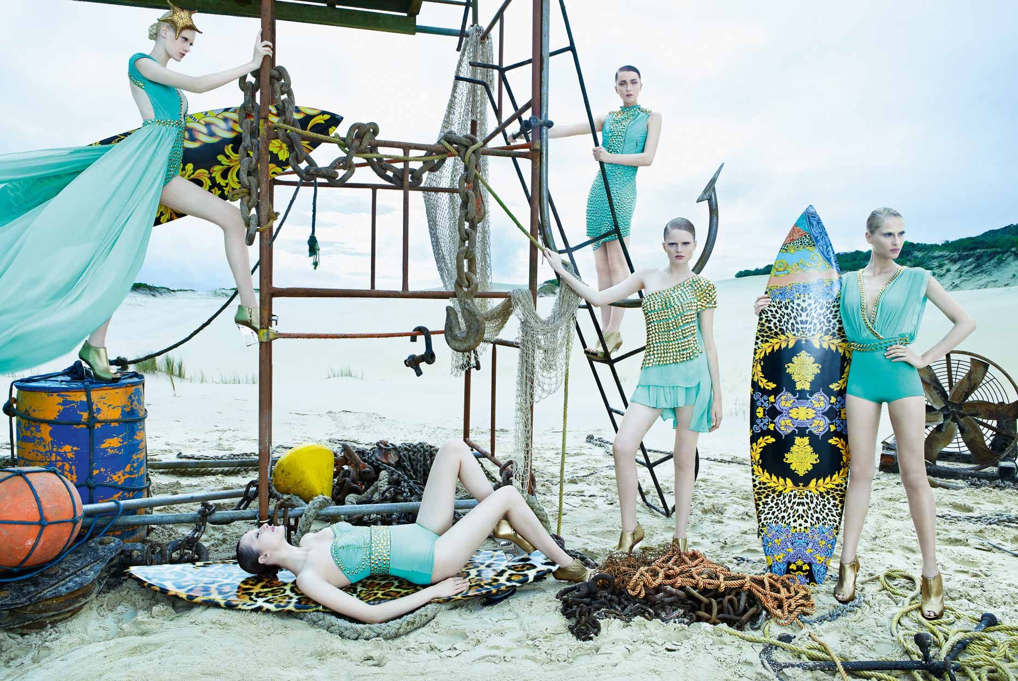 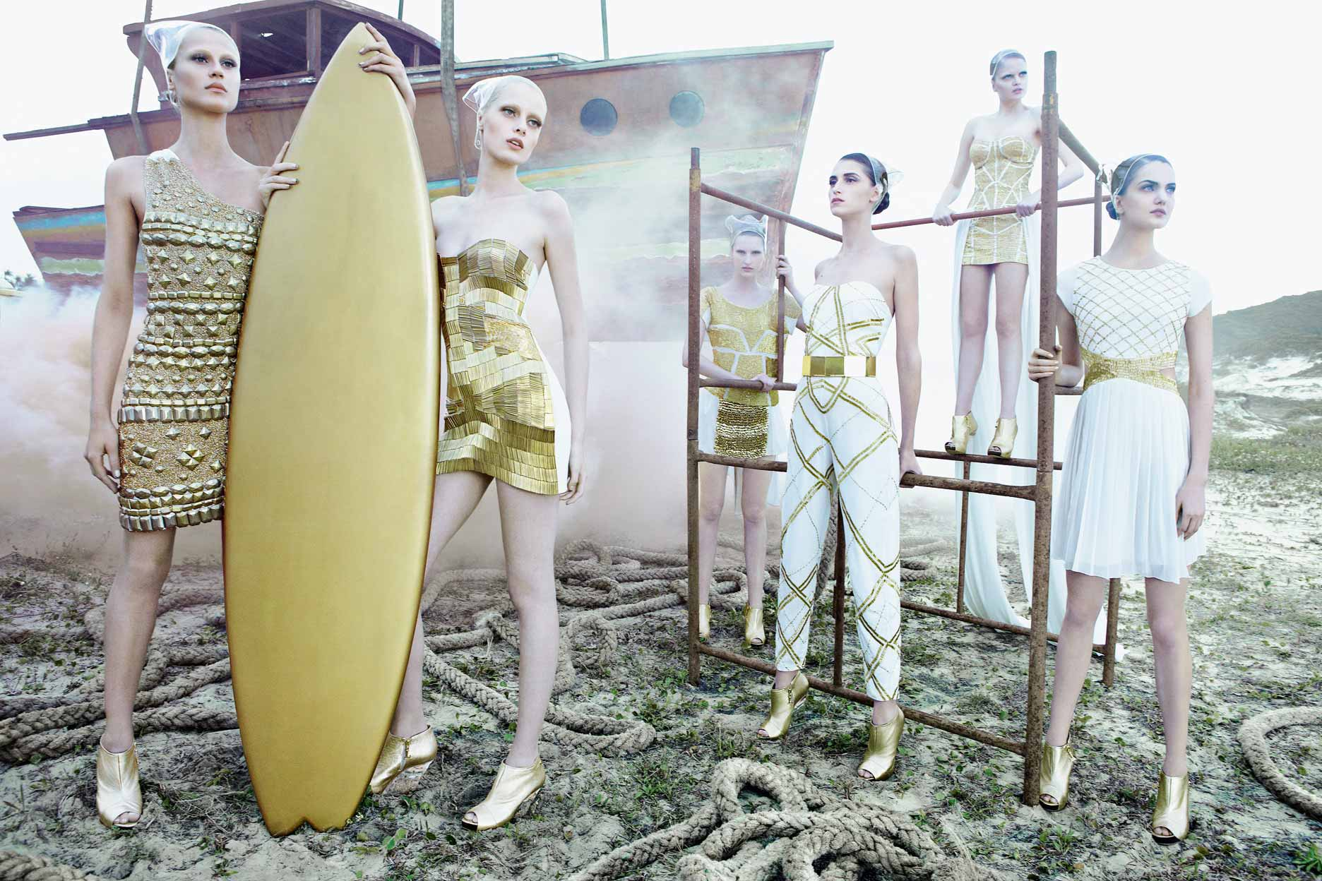

Figures 4 and 5. Mythical associations in the Spring/Summer 2013 Lança Perfume’s Campaign

In the images of Lança Perfume, as exemplified in the previous image, the visual materiality evidences the symbolization or mystification process of the images by the following aspects: (1) the reinforcement of graphic suggestion in the photographic image, by the strict separation between the figures and the background; (2) planning of the entire image due to the lack of perspective or angle; (3) the lack of tonality contrast, reducing the suggestion of light and shade and of volume, and (4) the lack of dynamism and suggestion of movement.

Besides that, the artificial skin tones of the models and the appearance of other elements of the landscape are other aspects of visual immateriality that reinforce the anti-naturalism and artificiality, suggesting, in an intentional and evident manner, the cultural or symbolic characteristic of the photographic image, and pointing out the surrealism or reality mystification process. The fashion culture invests idealization.

The images bring very tall and very thin models, without many curves, composing narrow and long figures, with a dominant vertical axis (fig. 4 and 5). This aesthetical representation goes against the naturalist concept. It is an expression of the idealization opposed to the natural, by considering the geometry, regularity and orientation as references to this ideal and transcendent model.

The height brings them closer to the sky. The “very high being” represents the transcendence, the strength, something unachievable, inaccessible, their infinity and eternity. The figures do not reveal the age, are not betrayed by the materiality, they are forever young; forever fixed in this beauty climax.

The images presented by Lança Perfume seem to capture a unique moment. They are free, too intentional (fig.4 and 5). Their function is to present a satisfaction dream, disguising the first human nature – the biological. The models of the advertising campaign are cooled and white marble statues. They have light and peaceful faces, without great expressivity.

The intention is not only to deny the natural, but also recreate it, reconstruct it, by means of an excessive fashion photography production. The use of filters suggests the digression of the image in relation with the spectator. This distance is reinforced by the gray tone of the filter. Gray is not a haughty color, it refers to self-sufficiency and self-control; it implies that these women dominate their faculties and opinions. It is a shield for external interference. Besides that, this atmosphere proposes a cold day at the beach, something bucolic.

The tones used for the clothing do not point in the direction of naturalness either (fig. 4 and 5). The most used tones, such as white and gold, reminds of holiness. Other colors are used and, sometimes, with very saturated shades. The yellow color is acid and it refers more to a chemical element other than a natural element.

The discretion and refinement of applying little makeup suggests that those women are naturally beautiful. Regarding the way their hair is used, the elegance and refinement of the well-made hairstyle, without any loose hair, indicated sophistication and dominance. It’s all a sign these women are superior and hold control over the situation, governing towards the perfection and order.

The women created by Lança Perfume, in the visual communication of the advertisement campaign for the Spring/Summer 2013, are seductive, glamorous, elegant and distant nereids, found in a world of sophistication, that goes beyond the ordinary things; the mysterious and supreme world that refuges the water princesses.

MYTHICAL ASSOCIATIONS IN IMAGES OF THE BRAND MORENA ROSA

Based on the same idea that the “mystification” is a trend observed in images of the brand collections studied, the indication and description of the mystic sense in images of the collection Spring/Summer 2012/2013 from brand Morena Rosa are presented here. This sense is composed by graphic-visual elements, such as the composition, formats and colors, as well as visual narrative elements, such as figures, attitudes and accessories.

In comparison with the feminine figures from the brand Lança Perfume, the presentation of models in the images of brand Morena Rosa is more naturalist. The blurs from pictures and the background are more blended; there is more investment in the contrasts and, consequently, the volumes of the figures (fig. 6 and 7). The camera positioning at the moment of shooting is frequently a little below the figure, composing a certain angle, sometimes it is central and other times, the angle comes from left to right and vice versa. In general, the visual part of the images and the figures are similar to the naturalist view. Therefore, the mystification of the images is more evident in the accessories, the objects and the models’ attitude.

The images’ context makes allusions to the medieval world, yet, in some images, there are contemporary aspects (fig.6 and 7). Thus, they show modern women who act and dream about power and dominance that were, previously, represented by mystic figures and situations.

The skin color is white, the tone is gold (fig.7); the European beauty model which, even with all the plurality speeches, remains dominant. There is no evidence of excessive makeup; the skin color corresponds to a natural human face color. In certain areas of the models’ faces, it is possible to note a darker tone, delimiting areas with light and shades coinciding with the face bones, which implies a more masculine face, showing strength and austerity (fig. 6 and 7).

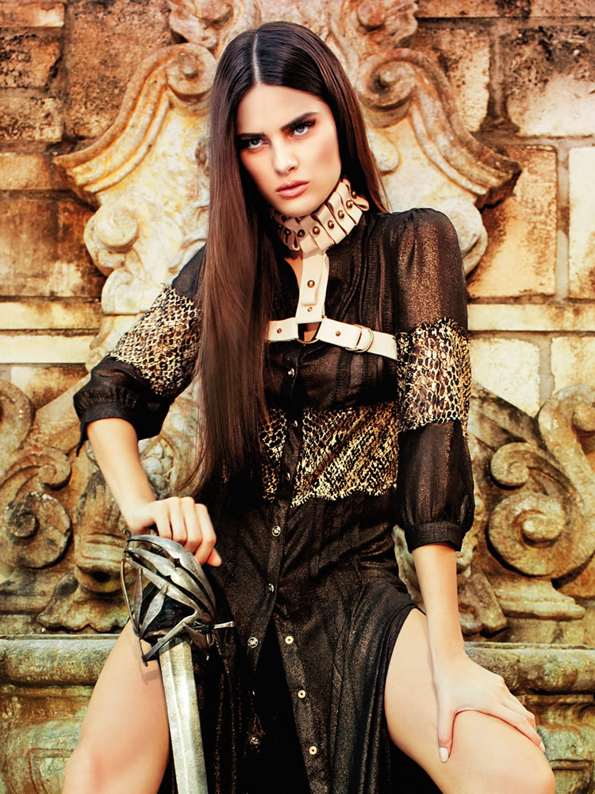 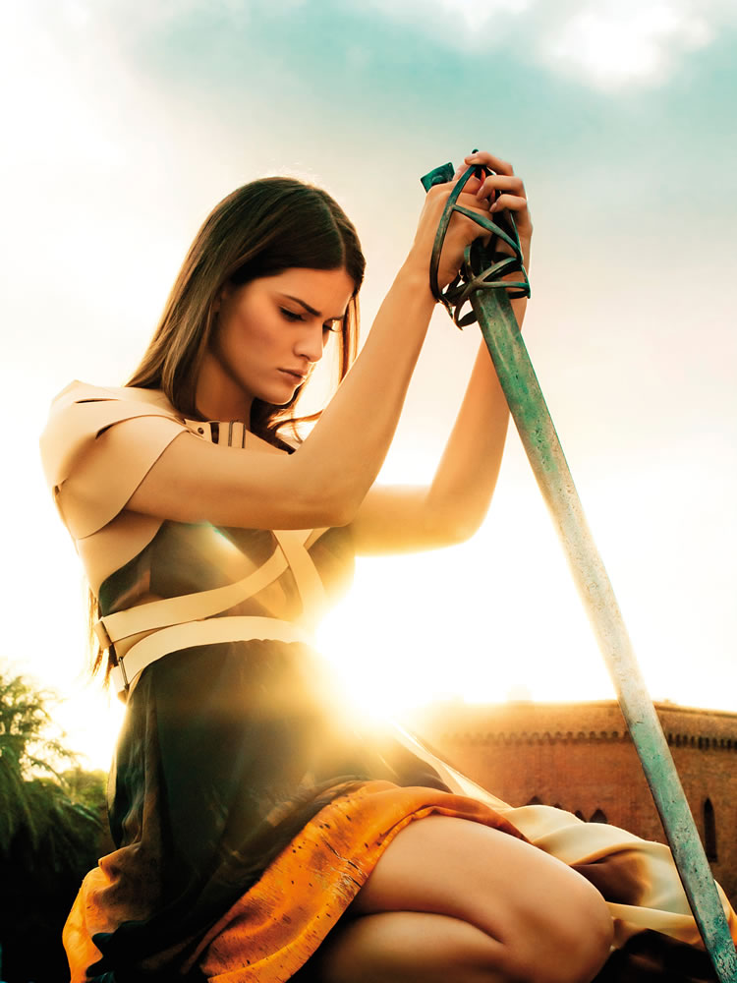

Figures 6 and 7. Mythical associations in the Spring/Summer 2013 Morena Rosa’s Campaign

The loose, long and straight hair proposes the senses of strength, naturalness and sensuality (fig. 6 and 7). They are more terrain and real women, who do not continuously inhabit the Gods’ world. There is a delight of materialism in the expression of the body’s muscles, volumes and flexibility, pointing out the sexiness (fig. 6 and 7). They are unable to rise to heaven because they are materially human.

The clothing presented in the images does not propose a Brazilian model either, even less if one takes into consideration that they refer to the Spring/Summer season. The European expression and the medieval theme disconnect the images of the brand from a so-called Brazilian identity; this seems to go against the official company’s information regarding what the brand intends to explore.

The general tones of the photography are gold and brown. They occur in the entire composition, suggesting the existence of a brownish layer that reveals a supposed aging intended for the pictures (fig. 6 and 7). The horse, spades (fig. 6 and 7) and candles were listed as elements of the scenario composition. Also as a fashion production, specifically for the models, the leather accessories are very present in the images (fig, 7); they compose shoulder pads and head adornments. The toughness, fits and configuration of the accessories remind of armors. The fashion production elements, along with the colors suggestion and the models’ contour, indicate a medieval or even previous mythology, which bring warrior women with Nordic appearance.

The images of Morena Rosa compose a symbolic and specific positioning for the brand, investing in the composition of warrior women, more active and familiar with the world reality. This brings them apart from the idealized and distant nymphs that were composed in the images of Lança Perfume. Therefore, even with an investment in the same trend of “mystification”, they propose another positioning for the brand, which is less sophisticated and blasé, and more present and active in daily journeys.

FINAL COMMENTS

Both brands present similar positioning; both develop clothing pieces for a socially and culturally similar consuming public. The communication and sales process of the brands are also very similar, with the same communication means.

The second part of the study is based on the idea that the fashion brands follow the general fashion trends, yet they should also inform and communicate their own positioning.

There was a tendency to “mystify” the collections and the brands. Both collections’ images had no focus on the products, but on the chosen theme.

The theme of each collection was not directly related with the seasons either. The images of brand Lança Perfume developed a theme associated with the beach and the marine culture, yet, this theme was not directly related to the sun. On the contrary, the distance, immobility, idealization, sophistication and glamour of symbolic, surreal and supernatural things were privileged.

The images of brand Morena Rosa composed a theme related with warrior goddesses, by means of the incorporation in the scenario of rustic elements, recollecting forests and medieval constructions, using obsolete objects as spades and thematic accessories. In this case, the season was not directly referred to; neither does the chosen outfit apply to the summer.

The same type of mystic investment was made by both brands; however, each one intended to define a different attitude. One brand is presented as something inspiring and unachievable and the other as something powerful, challenging and domineering.

A cultural text is any object or manifestation that is perceived or interpreted as an expression of a specific part of the culture symbolic collection. Thus, the images presented and described in this study are also interpreted as a part of the brands’ cultural collection, of the market commercial culture and the large and complex collection that composes the general culture.

The term representation which was already ascribed to all images, now became totally legitimate, hence, the photographic naturalism that is more evident in images presented by Morena Rosa is only one more possible artifice, likewise is the surrealism of the images presented by Lança Perfume. This aspect is initially discussed regarding the visual and conceptual elements of the visual language as elements that organize the pictures to represent things, objects, beings and people. They suggest, also, relations of proportionality, balance and other purely imaginative aspects in the flat and stationary images.

The metaphorical elements, on the other hand, compose a visual narrative in the observer’s mind, resetting parts of the imaginary world to tell a story. The connotative elements require an interactive association between the objective and subjective or emotional and cultural worlds, because they surpass the strict or literal meaning of the messages.

As shown in the discussion about fashion as a cultural system, fashion has always been included in the symbolic and mystical field, and its relevant is based on this, as object of studies that exceeds the technology and clothing ergonomics areas. The fashion field is notable symbolic-cultural, being essentially mystic as well.

Although the myth is part of the fashion dynamics, this study evidences the intentional investment of both brands in appealing directly to the mystification process, making the products become secondary elements. Consequently, they first sell an enchantment, a dreamlike state and the mythic-conceptual results. This may serve as a reinforcement that the clothing pieces are a support for the main product of the brands, which is composed by dreams, expressed in advertisements by aesthetic-symbolic elements and aspects.

REFERENCES

Randazzo, S. (1993) Mythmaking on Madison Avenue: How Advertisers Apply the Power of Myth and Symbolism to Create Leadership Brands. Chicago: Probus Pub. Co.

Caldas, D. (2004) Observatório de Sinais: Teoria e prática da pesquisa de tendências. São Paulo: SENAC.

Dondis, D. A. (1997). Sintaxe da linguagem visual. São Paulo: Martins Fontes.

Eliade, M. (1953). Traité d'histoire des religions. Payot.

Godart, Frédéric. Sociologie de la mode. La Découverte, 2010.

Gomez, L. S. R., Olhats, M. Pólo, C. (2011) Fashion Branding: uma relação emocional com o consumidor. Modapalavra E-periódico. Ano 4, n.8, jul-dez 2011, pp. 01-24.

Lipovetsky, G. (1987) L'Empire de l'éphémère: la mode et son destin dans les sociétés modernes. Paris : Gallimard.

Losada, T. (2010) A interpretação da imagem: subsídios para o ensino da arte. Rio de Janeiro: FAPERJ.

Tavares, M. C. (1998). A força da marca: como construir e manter marcas fortes. Habra.

Tybout, A. M., Calkins, T. (2006). Branding. São Paulo: Atlas 9